Experiment-5
Product Selling Application

Aim
To create a simple cloud-based Product Selling Application using a Software as a Service (SaaS) platform to manage product orders, calculate the total amount, and store customer details online.
Procedure
- Log in to Zoho Creator.
- Create a new application named Product Selling.
- Add fields such as Order ID, Customer Name, Email, Phone, Product Name, Category, Price, Quantity, Payment Status, Order Status, and Total Amount.
- Add the Deluge script to calculate the Total Amount.
- Publish the application.
- Enter customer and product details.
- Submit the form.
- Verify that the Total Amount is calculated and the order is saved in the cloud.

Implementation:

input.Total_Amount = input.price * input.Quantity;

if(input.Payment_Status == "Paid")
{
input.Order_Status = "Ordered";
}
else
{
input.Order_Status = "Pending";
}

OUTPUT:

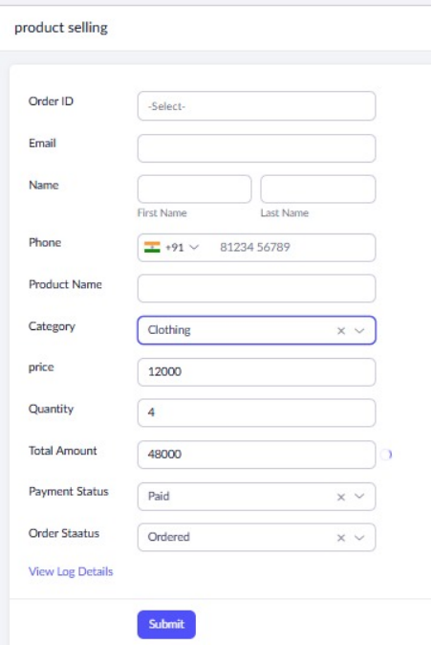

RESULT:
The Product Selling application was successfully created using Zoho Creator (SaaS).

